Nepal College of Information Technology
Unit Test
Fall 2011
Program : BE ELX/CE Time : 2 hrs
Semester : Fall (II) FM : 70
Subject : Electronic Devices PM : 35

- Candidates are requested to give their answer as far as practicable in their own words.
- The figure in the margin indicates the full marks
- Attempt ALL question
1. a) What do you mean by piecewise linear modeling of a diode. Find the piecewise linear model of a Silicon diode with I_{s} = 10⁻¹¹ A and n= 1.6 in the vicinity of operating point I_{D} = 1 mA. Also find the voltage across the diode. 2+5
b) Explain the I-V characteristics of a PN junction diode with necessary plot and equations. 8
2. a) Distinguish between transition region capacitance and diffusion region capacitance. 7
b) What do you mean by diode load-line? How is it drawn and how is operating point found graphically? 2+4+2
3. a) For the given circuit, determine the range of R that will result in V_{L} being maintained at 10 V. Given: I_{zk} = 1mA, P_{zmax} = 100 mW. 7
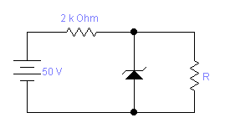
b) Explain the operation of a half wave rectifier. Calculate the average value and rms value of half wave rectified signal. 2+3+3
4. a) Draw the output waveform for the given circuits for the input sinusoidal signal having Vp = 12 V. 4+4
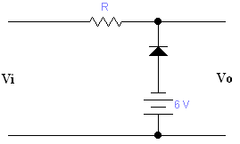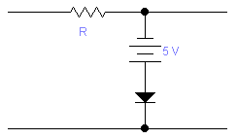
b) Explain how zener diode works as a voltage regulator. How do you select the value of series resistor Rs in a regulator circuit? 5+2
5. Write short notes on: (Any two) 5*2=10
a) Tunnel diode
b) Varactor diode
c) Forward and Reverse bias in PN junction diode
d) Difference between zener and avalanche effect.

